1. **Execute OVER and PARTITION BY Clause in SQL Queries, creating subtotals &Total Aggregations using SQL Queries.**

**Intially we will create and use a database called “coding_challenge01”:**

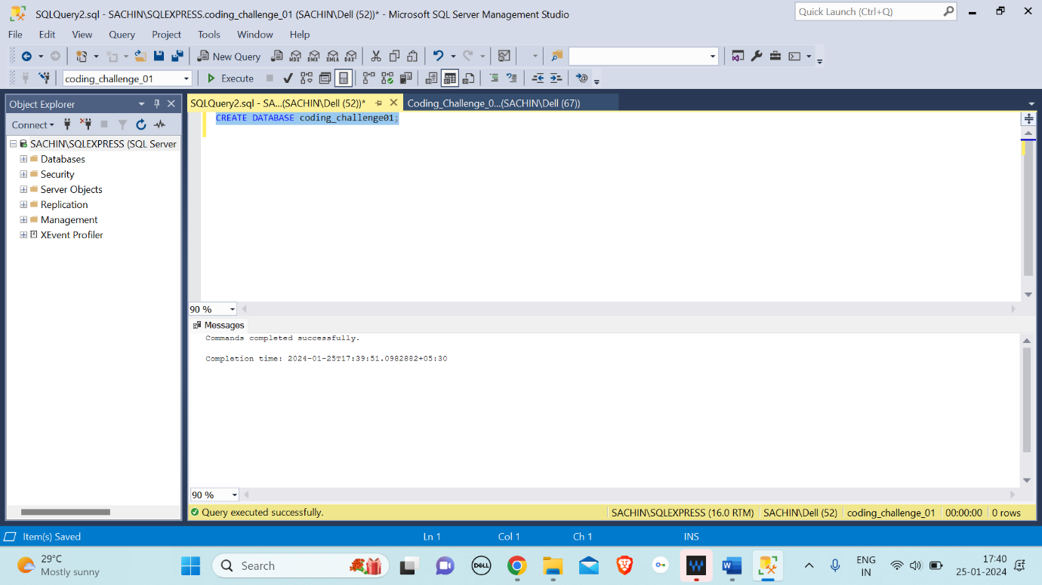

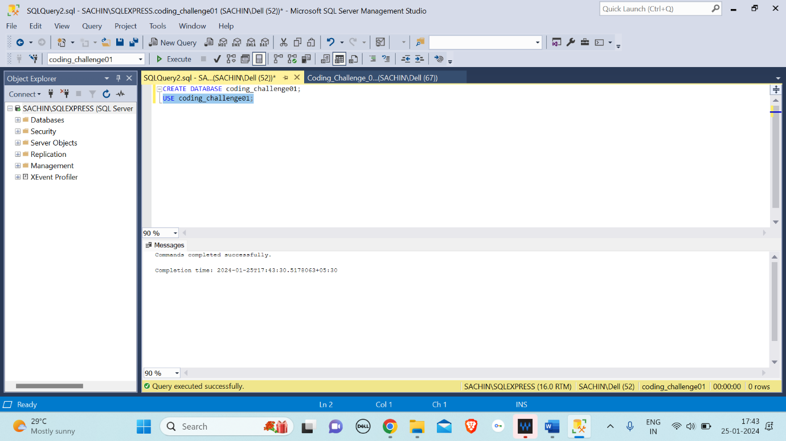

**After that, we will create a table named ‘SALES’ and insert all the values into it as shown below:**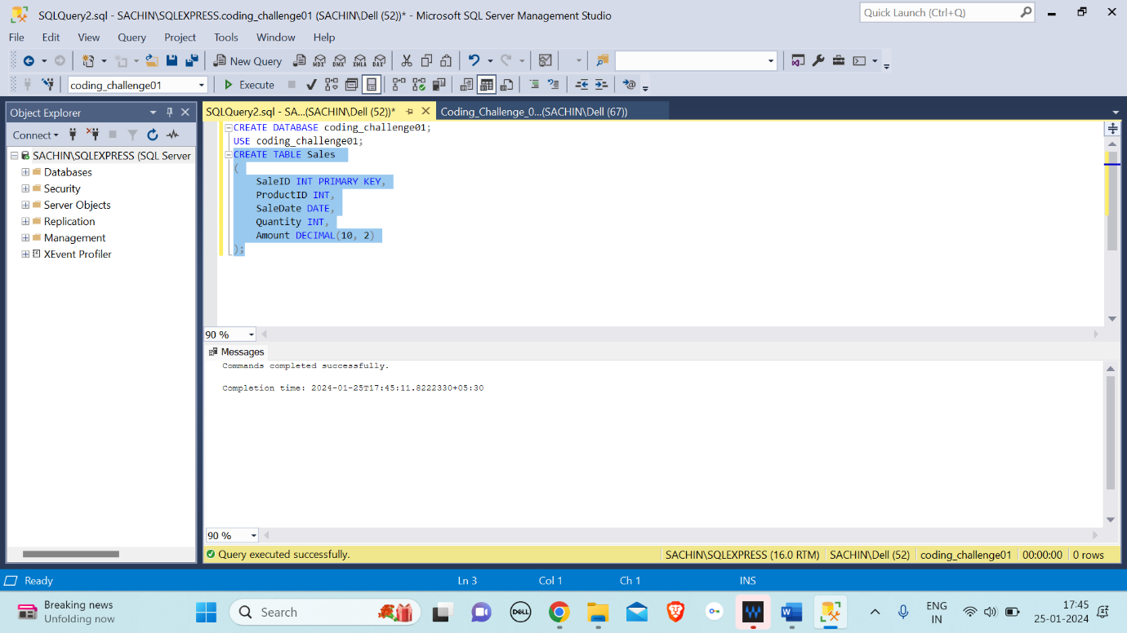

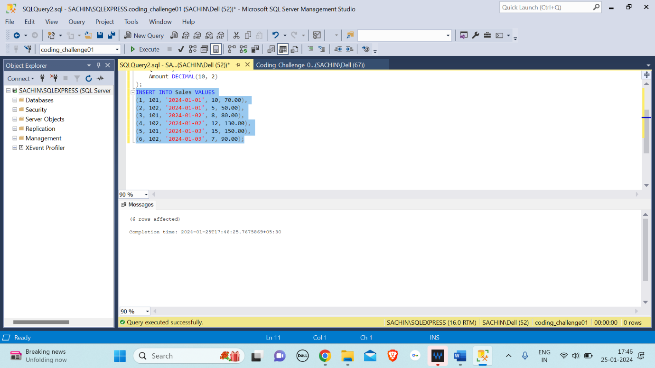

1. Execute OVER and PARTITION BY Clause in SQL Queries:

OVER Clause: It is defined as a window or user-specified set of rows within a query result set.

PARITITION BY: The 'PARTITION BY' clause in SQL is a subclause of the 'OVER' clause. It's used to split a large table into smaller, more manageable partitions.

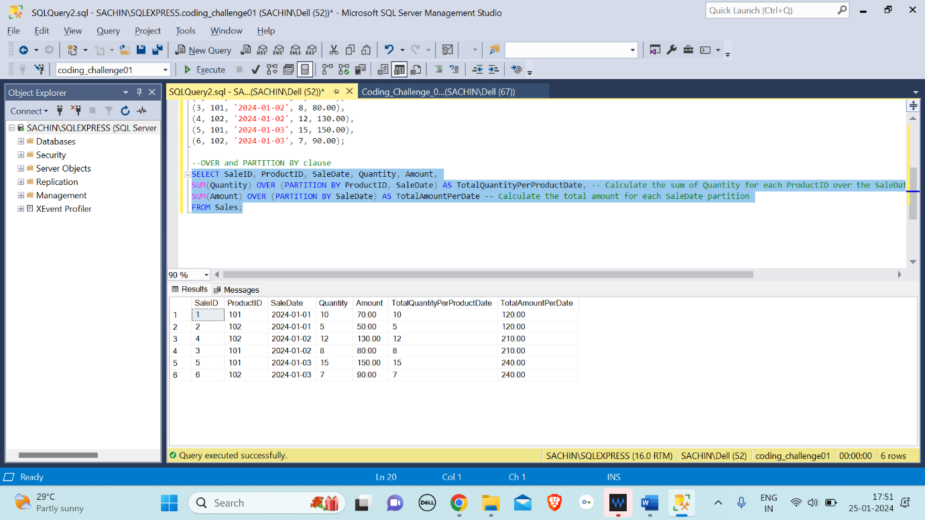

Uses the SUM function with the OVER clause to calculate the sum of Quantity for each combination of ‘ProductID’ and ‘SaleDate’.

Uses the SUM function with the OVER clause to calculate the total Amount for each ‘SaleDate’.

1. Creating subtotals &Total Aggregations using SQL Queries:

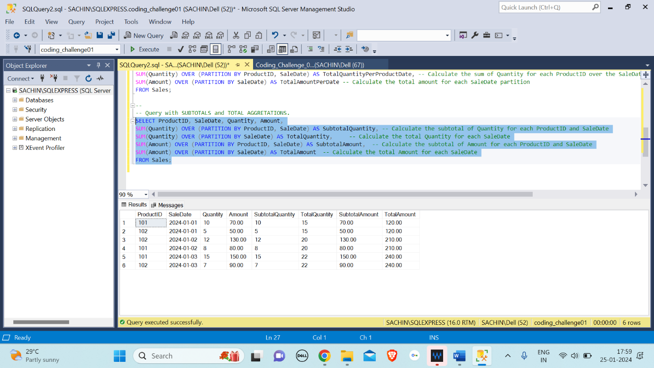

The SUM function with the OVER and PARTITION BY clauses is used to calculate subtotals and total aggregations for both Quantity and Amount.

The SubtotalQuantity and SubtotalAmount columns represent the subtotal for each combination of ProductID and SaleDate.

The TotalQuantity and TotalAmount columns represent the total for each SaleDate.